**T.C**

**İSTANBUL OKAN UNIVERSITY**

**FACULTY OF ENGINEERING AND NATURAL SCIENCES**

**DEPARTMENT OF COMPUTER ENGINEERING**



**PROJECT NAME**

PREPARED BY:

Student Name Surname

Student Number

SUPERVISOR:

Name Surname

İSTANBUL

202x

*“All the information in this project was obtained and presented in accordance with academic rules and ethical principles; I also declare that I have explicitly referenced the sources of all material that does not originate from this study, as required by these rules and principles. "*

*Student Name and Surname*

**SUMMARY**

**GRADUATION PROJECT**

**PROJECT NAME**

Project summary.

**Keywords:**

**ACKNOWLEDGMENT**

Our esteemed professor, who did not spare his interest and support in the planning, research, execution and formation of this thesis, benefited from his vast knowledge and experience and shaped our work in the light of scientific foundations with his guidance and information. I would like to express our endless thanks to Doç. Dr. Pınar Yıldırım.

TABLE OF CONTENTS

|  |  |
| --- | --- |
| SUMMARY | 3 |
| ACKNOWLEDMENTS | 4 |
| TABLE of CONTENTS | 5 |
| LIST of ABBREVIATIONS and ACRONYMS | 6 |
| LIST of FIGURES | 7 |
| LIST of TABLES | 8 |

**Contents**

LIST OF FIGURES 8

LIST OF TABLE 9

1) Introduction 11

**1.1) Objective of Study** 11

**1.2) Scope of Study** 11

**1.3) Significance of Study** 11

**1.4) Statement of Problem** 12

2) System Study & Analysis 13

**2.1) Principles of System Analysis** 13

**2.2) Existing System with Limitations** 13

3) Requirements Specification 14

**3.1) Hardware Requirements** 14

**3.2) Software Requirements** 14

4) Project System Modules or Components 15

**4.1) System Module-1 or Component-1** 15

**4.2) ...** 15

5) Description and Evaluation of the Proposed System 16

**5.1) Advantages of the Proposed System** 16

**5.2) Disadvantages and Shortcomings of the Proposed System** 17

6) Justification of the Proposed System 18

**6.1) Input Specification** 18

**6.2) Output Specification** 18

7) System Model (Unified Modeling Language - UML) 19

**7.1) Use Case Diagram** 19

**7.2) Activity Diagrams** 19

**7.3) System and Program Flowchart** 21

**7.4) Sequence Diagram** 21

**7.5) Class Diagram** 22

**7.6) Component Diagram** 23

8) Choice and Justification of Programming Language Used 25

9) Conclusion 26

10) References 27

**LIST OF ABBREVIATIONS AND ACRONYMS**

**Abbreviations Explanations and Acronyms**

**Hz : Hertz**

**F : Frekans**

**m : Meter**

**sn : Second**

LIST OF FIGURES

Figure 1. Hotel Management System. 16

Figure 2. Use Case Diagram of System. 19

Figure 3. Activity Diagrams-1. 20

Figure 4. Activity Diagrams-2. 21

Figure 5. Customer Information System Flowchart. 22

Figure 6. Class Diagram. 23

Figure 7. Component Diagram. 24

LIST OF TABLE

Table 1. Greek Alphabet. 24

Table 2. Name, Parameter Values and Difference. 25

**SYMBOLS**

C : Capacitance

q : Phase load

t : Time

# 1) Introduction

Lorem ipsum dolor sit amet, consetetur sadipscing elitr, sed diam nonumy eirmod tempor invidunt ut labore et dolore magna aliquyam erat, sed diam voluptua. At vero eos et accusam et justo duo dolores et ea rebum. Stet clita kasd gub rgren, no sea takimata sanctus est Lorem ipsum dolor sit amet, consetetur sadipscing elitr, sed diam nonumy eirmod tempor invidunt ut lab ore sit et dolore magna.

Lorem ipsum dolor sit amet, consetetur sadipscing elitr, sed diam nonumy eirmod tempor invidunt ut labore et dolore magna aliquyam erat, sed diam voluptua. At vero eos et accusam et justo duo dolores et ea rebum. Stet clita kasd gub rgren, no sea takimata sanctus est Lorem ipsum dolor sit amet, consetetur sadipscing elitr, sed diam nonumy eirmod tempor invidunt ut lab ore sit et dolore magna.

## **1.1) Objective of Study**

Lorem ipsum dolor sit amet, consetetur sadipscing elitr, sed diam nonumy eirmod tempor invidunt ut labore et dolore magna aliquyam erat, sed diam voluptua. At vero eos et accusam et justo duo dolores et ea rebum. Stet clita kasd gub rgren, no sea takimata sanctus est Lorem ipsum dolor sit amet, consetetur sadipscing elitr, sed diam nonumy eirmod tempor invidunt ut lab ore sit et dolore magna.

Lorem ipsum dolor sit amet, consetetur sadipscing elitr, sed diam nonumy eirmod tempor invidunt ut labore et dolore magna aliquyam erat, sed diam voluptua. At vero eos et accusam et justo duo dolores et ea rebum. Stet clita kasd gub rgren, no sea takimata sanctus est Lorem ipsum dolor sit amet, consetetur sadipscing elitr, sed diam nonumy eirmod tempor invidunt ut lab ore sit et dolore magna.

## **1.2) Scope of Study**

Lorem ipsum dolor sit amet, consetetur sadipscing elitr, sed diam nonumy eirmod tempor invidunt ut labore et dolore magna aliquyam erat, sed diam voluptua. At vero eos et accusam et justo duo dolores et ea rebum. Stet clita kasd gub rgren, no sea takimata sanctus est Lorem ipsum dolor sit amet, consetetur sadipscing elitr, sed diam nonumy eirmod tempor invidunt ut lab ore sit et dolore magna.

Lorem ipsum dolor sit amet, consetetur sadipscing elitr, sed diam nonumy eirmod tempor invidunt ut labore et dolore magna aliquyam erat, sed diam voluptua. At vero eos et accusam et justo duo dolores et ea rebum. Stet clita kasd gub rgren, no sea takimata sanctus est Lorem ipsum dolor sit amet, consetetur sadipscing elitr, sed diam nonumy eirmod tempor invidunt ut lab ore sit et dolore magna.

## **1.3) Significance of Study**

Lorem ipsum dolor sit amet, consetetur sadipscing elitr, sed diam nonumy eirmod tempor invidunt ut labore et dolore magna aliquyam erat, sed diam voluptua. At vero eos et accusam et justo duo dolores et ea rebum. Stet clita kasd gub rgren, no sea takimata sanctus est Lorem ipsum dolor sit amet, consetetur sadipscing elitr, sed diam nonumy eirmod tempor invidunt ut lab ore sit et dolore magna.

Lorem ipsum dolor sit amet, consetetur sadipscing elitr, sed diam nonumy eirmod tempor invidunt ut labore et dolore magna aliquyam erat, sed diam voluptua. At vero eos et accusam et justo duo dolores et ea rebum. Stet clita kasd gub rgren, no sea takimata sanctus est Lorem ipsum dolor sit amet, consetetur sadipscing elitr, sed diam nonumy eirmod tempor invidunt ut lab ore sit et dolore magna.

## **1.4) Statement of Problem**

Lorem ipsum dolor sit amet, consetetur sadipscing elitr, sed diam nonumy eirmod tempor invidunt ut labore et dolore magna aliquyam erat, sed diam voluptua. At vero eos et accusam et justo duo dolores et ea rebum. Stet clita kasd gub rgren, no sea takimata sanctus est Lorem ipsum dolor sit amet, consetetur sadipscing elitr, sed diam nonumy eirmod tempor invidunt ut lab ore sit et dolore magna.

Lorem ipsum dolor sit amet, consetetur sadipscing elitr, sed diam nonumy eirmod tempor invidunt ut labore et dolore magna aliquyam erat, sed diam voluptua. At vero eos et accusam et justo duo dolores et ea rebum. Stet clita kasd gub rgren, no sea takimata sanctus est Lorem ipsum dolor sit amet, consetetur sadipscing elitr, sed diam nonumy eirmod tempor invidunt ut lab ore sit et dolore magna.

# 2) System Study & Analysis

## **2.1) Principles of System Analysis**

Lorem ipsum dolor sit amet, consetetur sadipscing elitr, sed diam nonumy eirmod tempor invidunt ut labore et dolore magna aliquyam erat, sed diam voluptua. At vero eos et accusam et justo duo dolores et ea rebum. Stet clita kasd gub rgren, no sea takimata sanctus est Lorem ipsum dolor sit amet, consetetur sadipscing elitr, sed diam nonumy eirmod tempor invidunt ut lab ore sit et dolore magna.

Lorem ipsum dolor sit amet, consetetur sadipscing elitr, sed diam nonumy eirmod tempor invidunt ut labore et dolore magna aliquyam erat, sed diam voluptua. At vero eos et accusam et justo duo dolores et ea rebum. Stet clita kasd gub rgren, no sea takimata sanctus est Lorem ipsum dolor sit amet, consetetur sadipscing elitr, sed diam nonumy eirmod tempor invidunt ut lab ore sit et dolore magna.

Study to minimize ambiguities.

## **2.2) Existing System with Limitations**

Lorem ipsum dolor sit amet, consetetur sadipscing elitr, sed diam nonumy eirmod tempor invidunt ut labore et dolore magna aliquyam erat, sed diam voluptua. At vero eos et accusam et justo duo dolores et ea rebum. Stet clita kasd gub rgren, no sea takimata sanctus est Lorem ipsum dolor sit amet, consetetur sadipscing elitr, sed diam nonumy eirmod tempor invidunt ut lab ore sit et dolore magna.

Lorem ipsum dolor sit amet, consetetur sadipscing elitr, sed diam nonumy eirmod tempor invidunt ut labore et dolore magna aliquyam erat, sed diam voluptua. At vero eos et accusam et justo duo dolores et ea rebum. Stet clita kasd gub rgren, no sea takimata sanctus est Lorem ipsum dolor sit amet, consetetur sadipscing elitr, sed diam nonumy eirmod tempor invidunt ut lab ore sit et dolore magna.

# 3) Requirements Specification

Lorem ipsum dolor sit amet, consetetur sadipscing elitr, sed diam nonumy eirmod tempor invidunt ut labore et dolore magna aliquyam erat, sed diam voluptua. At vero eos et accusam et justo duo dolores et ea rebum. Stet clita kasd gub rgren, no sea takimata sanctus est Lorem ipsum dolor sit amet, consetetur sadipscing elitr, sed diam nonumy eirmod tempor invidunt ut lab ore sit et dolore magna.

Lorem ipsum dolor sit amet, consetetur sadipscing elitr, sed diam nonumy eirmod tempor invidunt ut labore et dolore magna aliquyam erat, sed diam voluptua. At vero eos et accusam et justo duo dolores et ea rebum. Stet clita kasd gub rgren, no sea takimata sanctus est Lorem ipsum dolor sit amet, consetetur sadipscing elitr, sed diam nonumy eirmod tempor invidunt ut lab ore sit et dolore magna.

## **3.1) Hardware Requirements**

Lorem ipsum dolor sit amet, consetetur sadipscing elitr, sed diam nonumy eirmod tempor invidunt ut labore et dolore magna aliquyam erat, sed diam voluptua. At vero eos et accusam et justo duo dolores et ea rebum. Stet clita kasd gub rgren, no sea takimata sanctus est Lorem ipsum dolor sit amet, consetetur sadipscing elitr, sed diam nonumy eirmod tempor invidunt ut lab ore sit et dolore magna.

Lorem ipsum dolor sit amet, consetetur sadipscing elitr, sed diam nonumy eirmod tempor invidunt ut labore et dolore magna aliquyam erat, sed diam voluptua. At vero eos et accusam et justo duo dolores et ea rebum. Stet clita kasd gub rgren, no sea takimata sanctus est Lorem ipsum dolor sit amet, consetetur sadipscing elitr, sed diam nonumy eirmod tempor invidunt ut lab ore sit et dolore magna.

## **3.2) Software Requirements**

Lorem ipsum dolor sit amet, consetetur sadipscing elitr, sed diam nonumy eirmod tempor invidunt ut labore et dolore magna aliquyam erat, sed diam voluptua. At vero eos et accusam et justo duo dolores et ea rebum. Stet clita kasd gub rgren, no sea takimata sanctus est Lorem ipsum dolor sit amet, consetetur sadipscing elitr, sed diam nonumy eirmod tempor invidunt ut lab ore sit et dolore magna.

Lorem ipsum dolor sit amet, consetetur sadipscing elitr, sed diam nonumy eirmod tempor invidunt ut labore et dolore magna aliquyam erat, sed diam voluptua. At vero eos et accusam et justo duo dolores et ea rebum. Stet clita kasd gub rgren, no sea takimata sanctus est Lorem ipsum dolor sit amet, consetetur sadipscing elitr, sed diam nonumy eirmod tempor invidunt ut lab ore sit et dolore magna.

# 4) Project System Modules or Components

Lorem ipsum dolor sit amet, consetetur sadipscing elitr, sed diam nonumy eirmod tempor invidunt ut labore et dolore magna aliquyam erat, sed diam voluptua. At vero eos et accusam et justo duo dolores et ea rebum. Stet clita kasd gub rgren, no sea takimata sanctus est Lorem ipsum dolor sit amet, consetetur sadipscing elitr, sed diam nonumy eirmod tempor invidunt ut lab ore sit et dolore magna.

Lorem ipsum dolor sit amet, consetetur sadipscing elitr, sed diam nonumy eirmod tempor invidunt ut labore et dolore magna aliquyam erat, sed diam voluptua. At vero eos et accusam et justo duo dolores et ea rebum. Stet clita kasd gub rgren, no sea takimata sanctus est Lorem ipsum dolor sit amet, consetetur sadipscing elitr, sed diam nonumy eirmod tempor invidunt ut lab ore sit et dolore magna.

## **4.1) System Module-1 or Component-1**

Lorem ipsum dolor sit amet, consetetur sadipscing elitr, sed diam nonumy eirmod tempor invidunt ut labore et dolore magna aliquyam erat, sed diam voluptua. At vero eos et accusam et justo duo dolores et ea rebum. Stet clita kasd gub rgren, no sea takimata sanctus est Lorem ipsum dolor sit amet, consetetur sadipscing elitr, sed diam nonumy eirmod tempor invidunt ut lab ore sit et dolore magna.

Lorem ipsum dolor sit amet, consetetur sadipscing elitr, sed diam nonumy eirmod tempor invidunt ut labore et dolore magna aliquyam erat, sed diam voluptua. At vero eos et accusam et justo duo dolores et ea rebum. Stet clita kasd gub rgren, no sea takimata sanctus est Lorem ipsum dolor sit amet, consetetur sadipscing elitr, sed diam nonumy eirmod tempor invidunt ut lab ore sit et dolore magna.

## **4.2) ...**

Lorem ipsum dolor sit amet, consetetur sadipscing elitr, sed diam nonumy eirmod tempor invidunt ut labore et dolore magna aliquyam erat, sed diam voluptua. At vero eos et accusam et justo duo dolores et ea rebum. Stet clita kasd gub rgren, no sea takimata sanctus est Lorem ipsum dolor sit amet, consetetur sadipscing elitr, sed diam nonumy eirmod tempor invidunt ut lab ore sit et dolore magna.

Lorem ipsum dolor sit amet, consetetur sadipscing elitr, sed diam nonumy eirmod tempor invidunt ut labore et dolore magna aliquyam erat, sed diam voluptua. At vero eos et accusam et justo duo dolores et ea rebum. Stet clita kasd gub rgren, no sea takimata sanctus est Lorem ipsum dolor sit amet, consetetur sadipscing elitr, sed diam nonumy eirmod tempor invidunt ut lab ore sit et dolore magna.

# 5) Description and Evaluation of the Proposed System

Lorem ipsum dolor sit amet, consetetur sadipscing elitr, sed diam nonumy eirmod tempor invidunt ut labore et dolore magna aliquyam erat, sed diam voluptua. At vero eos et accusam et justo duo dolores et ea rebum. Stet clita kasd gub rgren, no sea takimata sanctus est Lorem ipsum dolor sit amet, consetetur sadipscing elitr, sed diam nonumy eirmod tempor invidunt ut lab ore sit et dolore magna.

Lorem ipsum dolor sit amet, consetetur sadipscing elitr, sed diam nonumy eirmod tempor invidunt ut labore et dolore magna aliquyam erat, sed diam voluptua. At vero eos et accusam et justo duo dolores et ea rebum. Stet clita kasd gub rgren, no sea takimata sanctus est Lorem ipsum dolor sit amet, consetetur sadipscing elitr, sed diam nonumy eirmod tempor invidunt ut lab ore sit et dolore magna. Figure 1 shows Hotel Management System.

**HOTEL MANAGEMENT SYSTEM**

View Report

Enter Data

Administer

Staff

News/Events/

Level

Hotel management

Details

News/Event

Details

Applications/Result

Details

News/Event

Info

Staff Details

Enter

Info

Figure 1. Hotel Management System.

## **5.1) Advantages of the Proposed System**

* Lorem ipsum dolor sit amet, consetetur sadipscing elitr, sed diam nonumy eirmod tempor invidunt ut labore et dolore magna aliquyam erat, sed diam voluptua. At vero eos et accusam et justo duo dolores et ea rebum. Stet clita kasd gub rgren, no sea takimata sanctus est Lorem ipsum dolor sit amet, consetetur sadipscing elitr, sed diam nonumy eirmod tempor invidunt ut lab ore sit et dolore magna.
* Lorem ipsum dolor sit amet, consetetur sadipscing elitr, sed diam nonumy eirmod tempor invidunt ut labore et dolore magna aliquyam erat, sed diam voluptua. At vero eos et accusam et justo duo dolores et ea rebum. Stet clita kasd gub rgren, no sea takimata sanctus est Lorem ipsum dolor sit amet, consetetur sadipscing elitr, sed diam nonumy eirmod tempor invidunt ut lab ore sit et dolore magna. Figure1 shows Hotel Management System.

## **5.2) Disadvantages and Shortcomings of the Proposed System**

* Lorem ipsum dolor sit amet, consetetur sadipscing elitr, sed diam nonumy eirmod tempor invidunt ut labore et dolore magna aliquyam erat, sed diam voluptua. At vero eos et accusam et justo duo dolores et ea rebum. Stet clita kasd gub rgren, no sea takimata sanctus est Lorem ipsum dolor sit amet, consetetur sadipscing elitr, sed diam nonumy eirmod tempor invidunt ut lab ore sit et dolore magna.
* Lorem ipsum dolor sit amet, consetetur sadipscing elitr, sed diam nonumy eirmod tempor invidunt ut labore et dolore magna aliquyam erat, sed diam voluptua. At vero eos et accusam et justo duo dolores et ea rebum. Stet clita kasd gub rgren, no sea takimata sanctus est Lorem ipsum dolor sit amet, consetetur sadipscing elitr, sed diam nonumy eirmod tempor invidunt ut lab ore sit et dolore magna.

# 6) Justification of the Proposed System

Lorem ipsum dolor sit amet, consetetur sadipscing elitr, sed diam nonumy eirmod tempor invidunt ut labore et dolore magna aliquyam erat, sed diam voluptua. At vero eos et accusam et justo duo dolores et ea rebum. Stet clita kasd gub rgren, no sea takimata sanctus est Lorem ipsum dolor sit amet, consetetur sadipscing elitr, sed diam nonumy eirmod tempor invidunt ut lab ore sit et dolore magna. Figure1 shows Hotel Management System.

## **6.1) Input Specification**

Lorem ipsum dolor sit amet, consetetur sadipscing elitr, sed diam nonumy eirmod tempor invidunt ut labore et dolore magna aliquyam erat, sed diam voluptua. At vero eos et accusam et justo duo dolores et ea rebum. Stet clita kasd gub rgren, no sea takimata sanctus est Lorem ipsum dolor sit amet, consetetur sadipscing elitr, sed diam nonumy eirmod tempor invidunt ut lab ore sit et dolore magna. Figure1 shows Hotel Management System.

## **6.2) Output Specification**

Lorem ipsum dolor sit amet, consetetur sadipscing elitr, sed diam nonumy eirmod tempor invidunt ut labore et dolore magna aliquyam erat, sed diam voluptua. At vero eos et accusam et justo duo dolores et ea rebum. Stet clita kasd gub rgren, no sea takimata sanctus est Lorem ipsum dolor sit amet, consetetur sadipscing elitr, sed diam nonumy eirmod tempor invidunt ut lab ore sit et dolore magna. Figure1 shows Hotel Management System.

# 7) System Model (Unified Modeling Language - UML)

## **7.1) Use Case Diagram**

Lorem ipsum dolor sit amet, consetetur sadipscing elitr, sed diam nonumy eirmod tempor invidunt ut labore et dolore magna aliquyam erat, sed diam voluptua. At vero eos et accusam et justo duo dolores et ea rebum. Stet clita kasd gub rgren, no sea takimata sanctus est Lorem ipsum dolor sit amet, consetetur sadipscing elitr, sed diam nonumy eirmod tempor invidunt ut lab ore sit et dolore magna. Figure 2 shows Use Case Diagram of System.

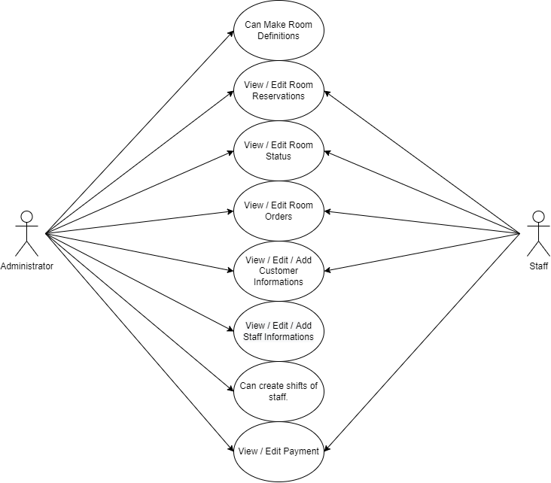

Figure 2. Use Case Diagram of System.

## **7.2) Activity Diagrams**

Lorem ipsum dolor sit amet, consetetur sadipscing elitr, sed diam nonumy eirmod tempor invidunt ut labore et dolore magna aliquyam erat, sed diam voluptua. At vero eos et accusam et justo duo dolores et ea rebum. Stet clita kasd gub rgren, Figure 2. Use Case Diagram of System.no sea takimata sanctus est Lorem ipsum dolor sit amet, consetetur sadipscing elitr, sed diam nonumy eirmod tempor invidunt ut lab ore sit et dolore magna. Figure 3 display Activity Diagrams-1.

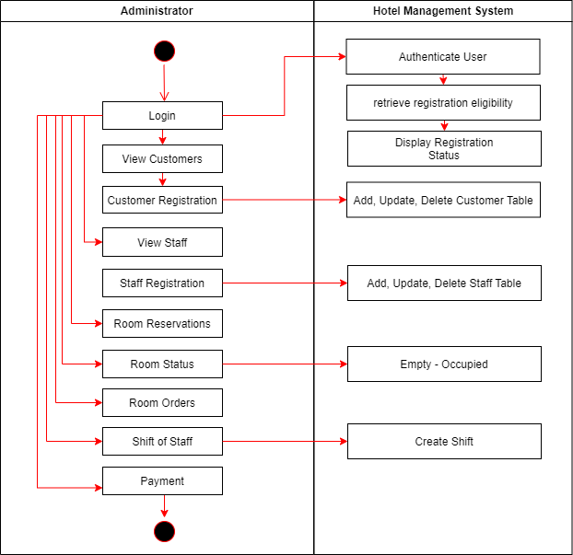

Figure 3. Activity Diagrams-1.

Figure 4 display Activity Diagrams-2.

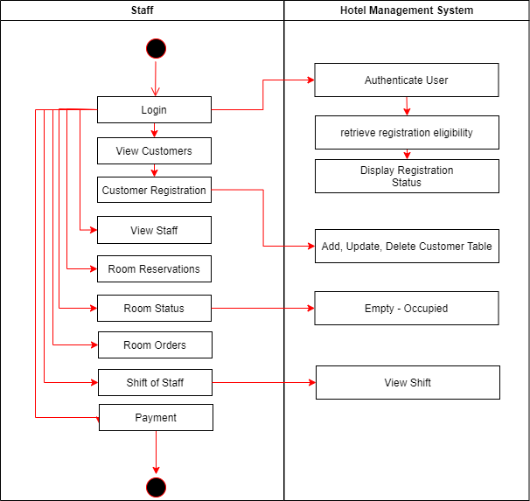

Figure 4. Activity Diagrams-2.

## **7.3) System and Program Flowchart**

Lorem ipsum dolor sit amet, consetetur sadipscing elitr, sed diam nonumy eirmod tempor invidunt ut labore et dolore magna aliquyam erat, sed diam voluptua. At vero eos et accusam et justo duo dolores et ea rebum. Stet clita kasd gub rgren, no sea takimata sanctus est Lorem ipsum dolor sit amet, consetetur sadipscing elitr, sed diam nonumy eirmod tempor invidunt ut lab ore sit et dolore magna. Figure1 shows Hotel Management System.

## **7.4) Sequence Diagram**

Lorem ipsum dolor sit amet, consetetur sadipscing elitr, sed diam nonumy eirmod tempor invidunt ut labore et dolore magna aliquyam erat, sed diam voluptua. At vero eos et accusam et justo duo dolores et ea rebum. Stet clita kasd gub rgren, no sea takimata sanctus est Lorem ipsum dolor sit amet, consetetur sadipscing elitr, sed diam nonumy eirmod tempor invidunt ut lab ore sit et dolore magna. Figure1 shows Hotel Management System. Figure 5 shows Customer Information System Flowchart.

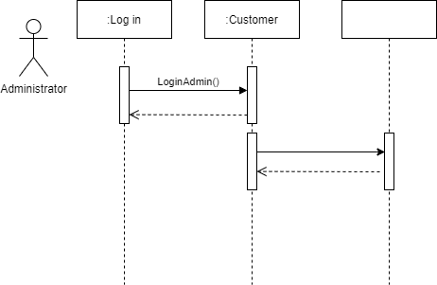

Customer Information System Flowchart

Figure 5. Customer Information System Flowchart.

## **7.5) Class Diagram**

Lorem ipsum dolor sit amet, consetetur sadipscing elitr, sed diam nonumy eirmod tempor invidunt ut labore et dolore magna aliquyam erat, sed diam voluptua. At vero eos et accusam et justo duo dolores et ea rebum. Stet clita kasd gub rgren, no sea takimata sanctus est Lorem ipsum dolor sit amet, consetetur sadipscing elitr, sed diam nonumy eirmod tempor invidunt ut lab ore sit et dolore magna. Figure1 shows Hotel Management System.

Lorem ipsum dolor sit amet, consetetur sadipscing elitr, sed diam nonumy eirmod tempor invidunt ut labore et dolore magna aliquyam erat, sed diam voluptua. At vero eos et accusam et justo duo dolores et ea rebum. Stet clita kasd gub rgren, no sea takimata sanctus est Lorem ipsum dolor sit amet, consetetur sadipscing elitr, sed diam nonumy eirmod tempor invidunt ut lab ore sit et dolore magna. Figure1 shows Hotel Management System. Figure 6 represents Class Diagram.

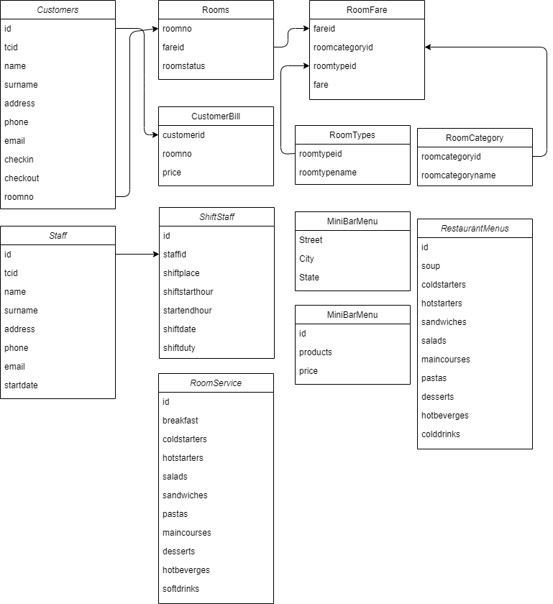

Figure 6. Class Diagram.

## **7.6) Component Diagram**

Lorem ipsum dolor sit amet, consetetur sadipscing elitr, sed diam nonumy eirmod tempor invidunt ut labore et dolore magna aliquyam erat, sed diam voluptua. At vero eos et accusam et justo duo dolores et ea rebum. Stet clita kasd gub rgren, no sea takimata sanctus est Lorem ipsum dolor sit amet, consetetur sadipscing elitr, sed diam nonumy eirmod tempor invidunt ut lab ore sit et dolore magna. Figure1 shows Hotel Management System.

Lorem ipsum dolor sit amet, consetetur sadipscing elitr, sed diam nonumy eirmod tempor invidunt ut labore et dolore magna aliquyam erat, sed diam voluptua. At vero eos et accusam et justo duo dolores et ea rebum. Stet clita kasd gub rgren, no sea takimata sanctus est Lorem ipsum dolor sit amet, consetetur sadipscing elitr, sed diam nonumy eirmod tempor invidunt ut lab ore sit et dolore magna. Figure 7 shows Component Diagram.

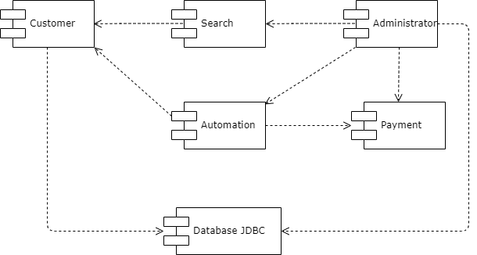

Figure 7. Component Diagram.

Table 1 shows Greek Alphabet.

Table 1. Greek Alphabet.

|  |  |  |  |  |  |
| --- | --- | --- | --- | --- | --- |
| Letter | Upper Case | Lower Case | Letter | Upper Case | Lower Case |
| Alfa | $$Α$$ | $$α$$ | Nu | $$Ν$$ | $$ν$$ |
| Beta | $$Β$$ | $$β$$ | Xi | $$Ξ$$ | $$ξ$$ |
| Gama | $$Γ$$ | $$γ$$ | Omikron | $$Ο$$ | $$ο$$ |
| Delta | $$Δ$$ | $$δ$$ | Pi | $$Π$$ | $$π$$ |
| Epsilon | $$Ε$$ | $$ε$$ | Ro | $$Ρ$$ | $$ρ$$ |
| Zeta | $$Ζ$$ | $$ζ$$ | Sigma | $$Σ$$ | $$σ$$ |
| Eta | $$Η$$ | $$η$$ | Tau | $$Τ$$ | $$τ$$ |
| Teta | $$Θ$$ | $$θ$$ | Upsilon | $$Υ$$ | $$υ$$ |
| Iota | $$Ι$$ | $$ι$$ | Phi | $$Φ$$ | $$φ$$ |
| Kappa | $$Κ$$ | $$κ$$ | Chi | $$Χ$$ | $$χ$$ |
| Lambda | $$Λ$$ | $$λ$$ | Psi | $$Ψ$$ | $$ψ$$ |
| Mu | $$Μ$$ | $$μ$$ | Omega | $$Ω$$ | $$ω$$ |

# 8) Choice and Justification of Programming Language Used

Lorem ipsum dolor sit amet, consetetur sadipscing elitr, sed diam nonumy eirmod tempor invidunt ut labore et dolore magna aliquyam erat, sed diam voluptua. At vero eos et accusam et justo duo dolores et ea rebum. Stet clita kasd gub rgren, no sea takimata sanctus est Lorem ipsum dolor sit amet, consetetur sadipscing elitr, sed diam nonumy eirmod tempor invidunt ut lab ore sit et dolore magna. Figure1 shows Hotel Management System.

Lorem ipsum dolor sit amet, consetetur sadipscing elitr, sed diam nonumy eirmod tempor invidunt ut labore et dolore magna aliquyam erat, sed diam voluptua. At vero eos et accusam et justo duo dolores et ea rebum. Stet clita kasd gub rgren, no sea takimata sanctus est Lorem ipsum dolor sit amet, consetetur sadipscing elitr, sed diam nonumy eirmod tempor invidunt ut lab ore sit et dolore magna. Table 2 displays Name, Parameter Values and Difference.

Table 2. Name, Parameter Values and Difference.

|  |  |  |  |
| --- | --- | --- | --- |
| Name | Parameter-1 | Parameter-2 | Difference |
|  |  |  |  |
| X1 | 110 | 103 | +7 |
| X2 | 223 | 214 | +9 |
| X3 | 197 | 120 | +77 |
| X4 | 134 | 121 | +13 |
| X5 | 202 | 210 | -8 |
|  | Mezun |  |  |
| X6 | 24 | 20 | +4 |
| X7 | 43 | 53 | -10 |
| X8 | 3 | 11 | -8 |
| X9 | 9 | 4 | +5 |
| X10 | 53 | 52 | +1 |
| Sum | 998 | 908 | 90 |

# 9) Conclusion

Lorem ipsum dolor sit amet, consetetur sadipscing elitr, sed diam nonumy eirmod tempor invidunt ut labore et dolore magna aliquyam erat, sed diam voluptua. At vero eos et accusam et justo duo dolores et ea rebum. Stet clita kasd gub rgren, no sea takimata sanctus est Lorem ipsum dolor sit amet, consetetur sadipscing elitr, sed diam nonumy eirmod tempor invidunt ut lab ore sit et dolore magna. Figure1 shows Hotel Management System.

Lorem ipsum dolor sit amet, consetetur sadipscing elitr, sed diam nonumy eirmod tempor invidunt ut labore et dolore magna aliquyam erat, sed diam voluptua. At vero eos et accusam et justo duo dolores et ea rebum. Stet clita kasd gub rgren, no sea takimata sanctus est Lorem ipsum dolor sit amet, consetetur sadipscing elitr, sed diam nonumy eirmod tempor invidunt ut lab ore sit et dolore magna. Figure1 shows Hotel Management System.

# 10) References

Öztürk E., Başaran E., Aksoy S., (2011), “Modeling of Ground Penetrating Radar”. In: A. S. Turk, A. K. Hocaoglu, A. A. Vertiy, Editors, “Subsurface Sensing Book”, Wiley & Sons Inc.

Aksoy S., (2003), “Dalga Kılavuzlarında Elektromanyetik Zaman Domeni Analizlerinin Yeni Bir Analitik Metotla İncelenmesi”, Doktora Tezi, Gebze Yüksek Teknoloji Enstitüsü.

Bourgeade A., (2002), “Dynamic load balancing computation of pulses propagating in a nonlinear medium”, 2nd International Conference on Parallel Processing Workshops, 246-253, Orlando, FL, USA, 18-21 August.

Fidel B., Heyman E., Kastner R., Ziolkowaski R. W., (1997), “Hybrid Ray–FDTD moving window approach to pulse propagation”, Journal of Computational Physics, 138 (5), 480-500.

Haskell R. E., Case C. T., (1994), “Transient Signal Propagation in Lossless Isotropic Plasmas”, Technical Report No: ARCRL-66-234, Department of Electrical Engineering, Columbia University, USA.

Praokis J., Salehi M., (2007), “Digital Communications”, 5th Edition, McGraw-Hill.

ResGaz 1, Elektrik Piyasası Kanunu, 3 Mart 2001 tarih ve 24335 sayılı Resmi Gazete.

ResGaz 2, Dengeleme ve Uzlaştırma Yönetmeliği, 14 Nisan 2009 tarih ve 27200 sayılı Resmi Gazete.

Web 2, (2013), <http://www.remcom.com/xgtd>, (Erişim Tarihi (Access Date): 24/11/2013).

Williams D., (2005), “Screw Less Clip Mounted Computer Drive”, U.S. Patent 6,885,550.

Zang X. D., (2005), Wireless power transfer in concrete via coupled magnetic resonance, IEEE Transactions on Antennas And Propagation, 61 (3), 1378-1384.